<https://www.youtube.com/watch?v=tJp1hCJ7mUU&list=PLemSd_GDX4aCj8nmR2ZiI5TrqBQi1dB6M>

-Operating System

-> Process

-> Thread

In Operating system each application run by a process. Below mention app (Google chrome, Ms word) are run by process. Background process are windows service which are run in background.

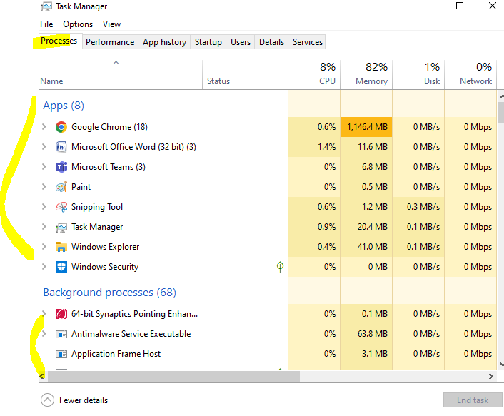

Thread:

A Thread is a unit which execute the code/logic under a application.

* Every application by default contains one thread to execute the program and the program and that is known as Main Thread. So, every program is by default single threaded model.

Every application by default one thread to execute the logic , this thread call as main thread.

Single thread:

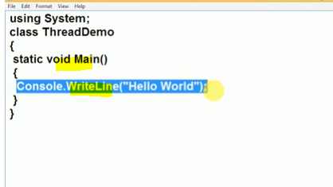

Add name of current Thread and print the current thread name.

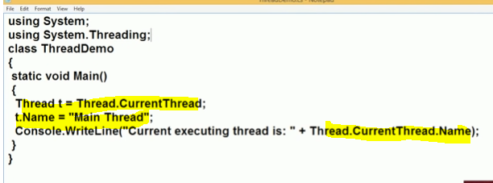

Run Code: Output

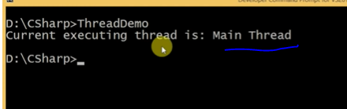

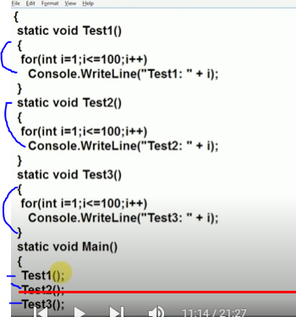

In Single Thread programming all method are call one after one.

Drawback of single thread: In a scenario if method Test1(),Test2(),Test3() doing some database operation. If test() method take more time to perform db operation , bcz inside db taking more time. Then test2() wait until finished test1() method.

